Future Land Price Prediction
Business-to-Business (B2B) and Business-to-Customer (B2C) Project Documentation

Executive Summary
The Land Price Prediction System is a machine learning-based analytical solution designed for real estate companies, land developers, property investment firms, and property analytics platforms. The system predicts land prices using multiple geographical, environmental, and infrastructure-related features.
The goal of this solution is to provide real estate businesses with a data-driven tool that improves land valuation accuracy and supports strategic investment decisions.
Business Problem
Real estate companies and property developers often face challenges when estimating land prices. Land value is influenced by many factors such as infrastructure development, accessibility, zoning regulations, and environmental risks.
Traditional land valuation methods rely heavily on manual analysis and expert judgment, which may lead to inaccurate pricing and financial risk.
Businesses require an intelligent system that can analyse large datasets and predict land prices quickly and accurately.
Business Objectives
The primary objectives of this project are:
• Develop a predictive system that estimates land prices accurately
• Help real estate companies evaluate land investment opportunities
• Reduce manual analysis and pricing errors
• Enable data-driven decision making in property investment
• Provide scalable predictive models for real estate platforms

Dataset Description
The dataset used in this project contains various land attributes collected from different cities and states. These attributes represent the factors that influence land pricing.
Input Features
- city
- state
- locality
- city_tier
- dist_city_center_km
- dist_highway_km
- dist_transport_km
- dist_amenities_km
- historical_growth_pct
- population_growth_pct
- road_quality_score
- land_area_sqft
- utility_access
- govt_dev_plan
- flood_risk
- zoning
These features represent geographic location, infrastructure availability, development planning, and environmental risk.
Target Variable
- predicted_price_sqft_2026
This variable represents the price of land per square foot in Indian Rupees.

Machine Learning Models Used:
Model –Random Forest Regressor Algorithm
Model File: land_price_pipeline.pkl
Example input:
"city": "Jaipur",
"state": "Rajasthan",
“locality”: “Chomu”
"city_tier": 2,
"zoning": "Agricultural",
"land_area_sqft": 10776.99 ,
"dist_city_center_km": 18.43,
"dist_highway_km": 0.94,
"dist_transport_km": 2.77,
"dist_amenities_km": 1.83,
"historical_growth_pct": 14.17,
"population_growth_pct": 2.08,
"road_quality_score": 5.89,
"utility_access": 1,
"govt_dev_plan": 1,
"flood_risk": 0,
“current_price”: 4830.36
Example output:
Current Price per sqft: 4830.36
Future Price per sqft: 8615.87
Expected Profit per sqft: 3785.51
ROI %: 78.37
Model Evaluation
The performance of the models was evaluated using standard regression metrics.
Evaluation Metrics
- R² Score
- Mean Squared Error (MSE)
- Root Mean Squared Error (RMSE)
These metrics measure prediction accuracy and help identify the best performing model.
Technology Stack
- Programming Language
- Python 3.13.5
- Libraries Used
- pandas → Data loading & manipulation
- numpy → Numerical operations
- scikit-learn →
  - Train-test split
  - Evaluation metrics (R², RMSE)
  - Ordinal Encoding (categorical preprocessing)
- Random Forest Regressor→ Best performing model for prediction
- pickle → Model & encoder saving/loading
- matplotlib → Data visualization
Requirements.txt
- pandas==2.2.3
- numpy==2.1.3
- scikit-learn==1.6.1
- Random Forest Regressor == 1.3.2
- matplotlib==3.9.2

Future Enhancements
The system can be improved by:
• Integrating Geographic Information System (GIS) data.
• Adding satellite imagery analysis.
• Deploying the model as a cloud API.
• Creating real-time real estate analytics dashboards.
Project File Structure
- Batch 2 Real-Estate.zip
- Final_land_price_65k.csv
- Future Land prediction (Business and Customer Documentation).docx
- Final_documentation.docx
- New_Business_Model_Training.ipynb
- land_price_pipeline.pkl
- streamcode.py
- requirements.txt

User prediction Dashboard

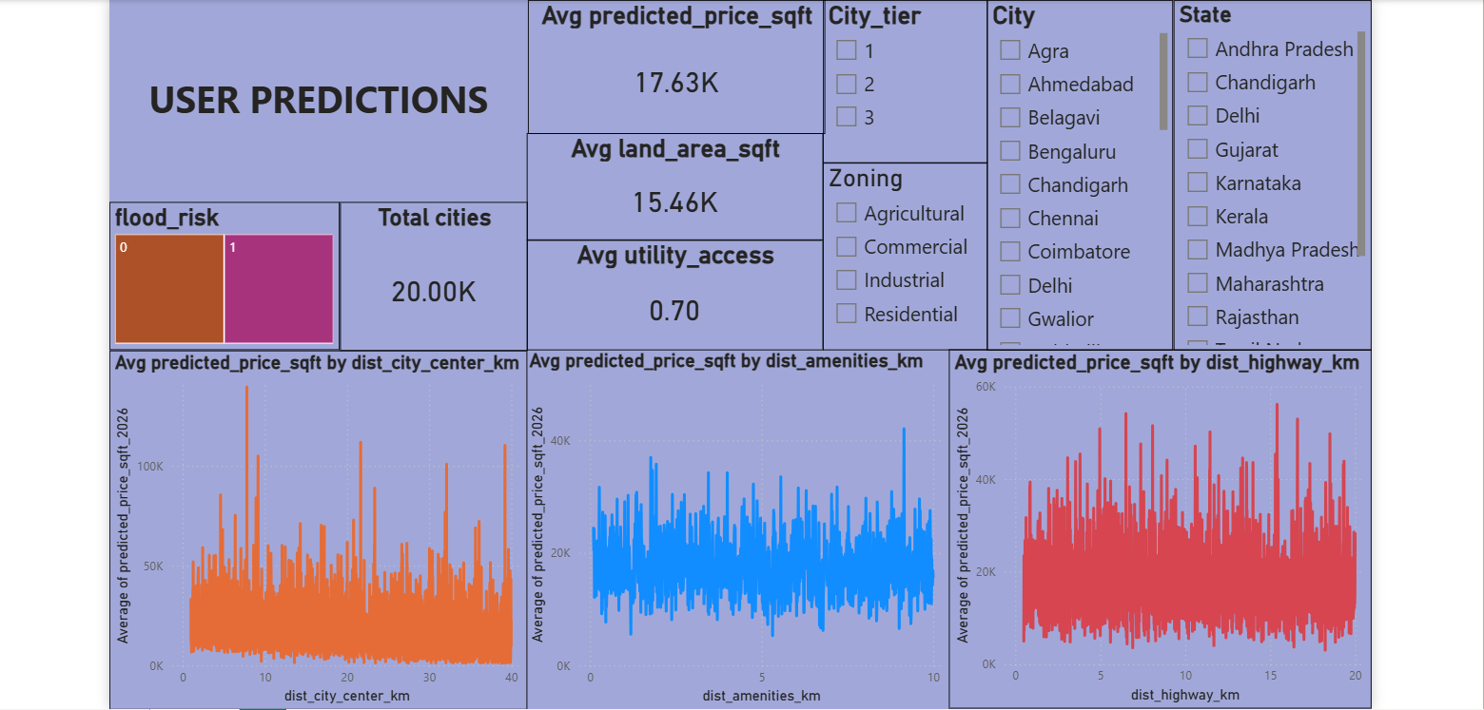

Conclusion
The Land Price Prediction System demonstrates the use of machine learning algorithms to analyse multiple land-related factors and accurately predict land prices. This system provides valuable insights for real estate businesses, helping them evaluate investment opportunities and improve property valuation strategies.
The project highlights the potential of data-driven solutions in modern real estate analytics and enterprise decision support systems.

